Wigan Wheelers and Triathlon Club - Open 10 Miles TT L1015
Saturday 19th MAY 2023 - START SHEET
PLEASE READ ALL THE RACE DETAILS CAREFULLY
If you are a UNDER 18 Competitor – please ask your parent / guardian to also read this, thank you
Promoted on behalf of Cycling Time Trials under their rules and regulations

Event Secretary: Amanda Asbridge - 07720060021 Time Keepers: Derek Black and Tracy Moore

Headquarters: Sizergh, Nannypie Lane, Nr Kendal, LA8 8DZ (Lay-By). There are no toilet facilities available
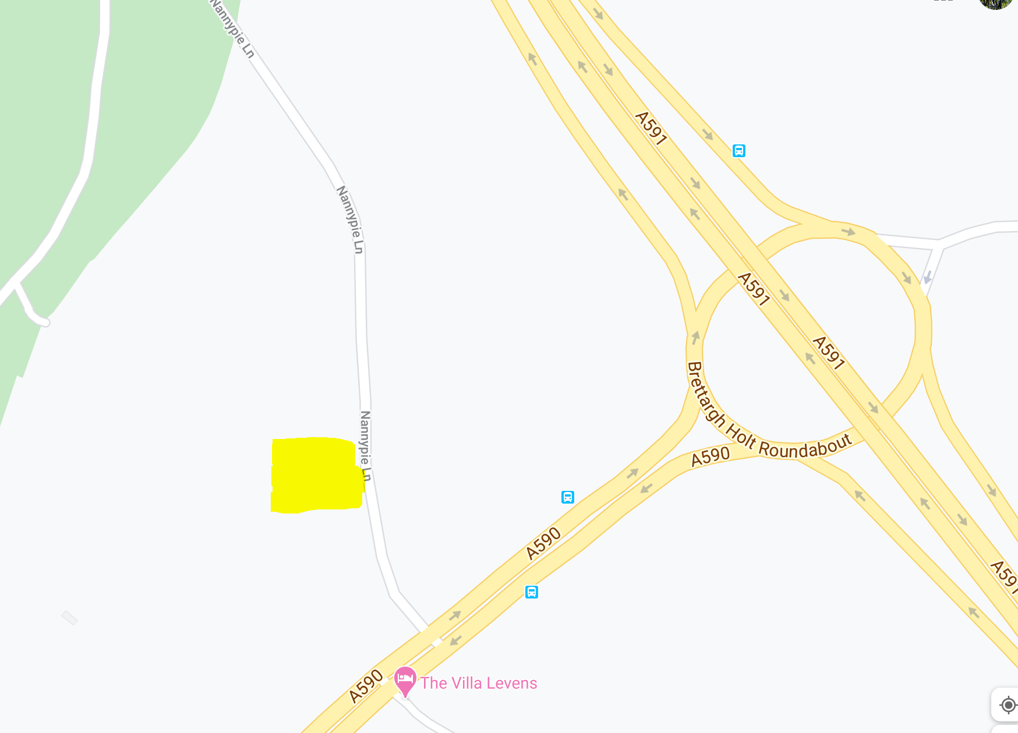

HQ opens from 17.00 First rider off 18.01
Please be considerate when parking and social distance at all times. Do not get changed, urinate or warm up in front of or in close proximity of any residential home or the Strickland Arms Public House.
Please allow 10 minutes to ride to the start. From the HQ- follow the road back to the A590, turn left to the RAB encircle and ride back up the A590 to the Start (DO NOT PASS THE START YOU WILL BE DISQUALIFIED once the event has started)

Course: L1015 – description
START in lay-by alongside the A590 approximately 500 yards south-west of junction with southbound A6 in line with the three white marks on kerb edge which are 20 yards west of a drainage grate which is 5 yards west of the eastern end of footpath and 25 yards east of a drainage grate almost in line with the SOS telephone point. This mark is directly in line with a wooden fence post with two angled supports in the hedge and almost in line with a ‘Please take your litter home sign’. Proceed along the A590 in a south-westerly direction to encircle the roundabout on Lindale by-pass (5.243 miles). Retrace along the A590 to FINISH in line with the metal cover in northern grass verge embossed ‘Charlton Iron Works Sheffield’ which is approximately 12 yards east of large road sign on slip-road to the A6 approximately 90 yards short of Levens Bridge/Levens Village road (10 MILES).
CTT Regulation 17: Signing-on & signing-out sheet
- The competitors in all types of events must make themselves aware of any special instructions for the event and sign the official signing on sheet when collecting their number.
- In type A events a competitor must return to the HQ either during the event or within a reasonable time after the last rider has finished the event and sign the official signing out sheet.
IT IS THE RIDERS RESPONSIBILITY TO SIGN OUT AFTER THE EVENT OR AN AUTOMATIC DNF WILL BE AWARDED. Under 18’s can be accompanied by an adult.
The following Local Regulations have been approved by the National Committee in accordance with Regulation 38. Any breaches may lead to disciplinary action being taken.

Local Reg No. 5 In all events, competitors prior to starting are not permitted to ride past the finishing timekeeper during the duration of the event.
Local Reg No.6 Any competitors making a U turn in the vicinity of the start or finish will be disqualified from the event.
Local Reg No.10 Course L1015-warming up on the course is not permitted during the duration of the event.
Local Reg No. 12 – NO PARKING on the car park or on the frontage of the Strickland Arms.
Local Reg No.15 Riders must keep to the left hand side of the road except when overtaking. Failure to comply with the above may lead to disqualification. Riders must give their number at the finish and elsewhere on the course where requested.
IN ADDITION TO THE ABOVE
Riders must give their number at the finish and elsewhere on the course if requested.
Riders MUST NOT STAND in the road at the start or finish. (This constitutes obstruction and is a breach of regulations)
Riders must NOT ride with their heads down.
Rider Safety Helmets: All competitors under the age of 18 and/or juniors must wear a HELMET of HARD/SOFT SHELL construction that conforms to a recognised Standard (See Regulation 15). Cycling Time Trials strongly recommends ALL competitors to wear such a helmet.
Competitor Machines - Lights: CTT Regulation 14(i) and (j) – Compulsory Use of Working Rear Red Light AND Working Front White Light
All lights need to be fully charged and should remain lit for the duration of the event

"NO HELMET, NO FRONT AND REAR LIGHT
= NO RIDE"

This event may be subject to a Doping Control
It is your responsibility to check As soon as you have finished you should return to the event HQ as it is your responsibility to check if you are required for Doping Control Race numbers required for Doping Control will be displayed at the HQ adjacent to the result board If your number is displayed you should report immediately to Doping Control which will be nearby Remember, it is up to you to check and ensure that you comply If required you must report to Doping Control after finishing without delay.
Prize List
Prize | All Competitors | Women | Junior and Juvenile |  | Espoir and Seniors | V40 | V50 | V60 | V70  V80
1st | 40 | 40 | 40 |  | 40 | 30 | 30 | 30 | 30
2nd | 30 | 30 | 30 |  | 30
3rd | 25 | 25 |  |  | 25
4th | 20 |  | 1st Trike |  | 1st Road Bike (male and female) | 1st Tandem
5th | 15 |  | 30 |  | 30 (each) | 30

Fastest team of 3 - £15 each (One rider one prize apart from team prize)
Once we have finalised results we will reach out (via email or text) to you to arrange payment of prize money via bank transfer.
Provisional results will be available via the clubs facebook page on the night - https://www.facebook.com/WWCCWTC

DRAFTING
If you should catch up another rider you should try to pass as quickly as possible and must not in any other circumstances ride close behind so that you take shelter from the wind. You must set your own pace and not use another rider as a pace maker. The onus on avoiding company riding shall be on the rider overtaken. Nor is it in order to ride alongside and even to ride a few metres behind for any appreciable distance. In the spirit of the sport, caught riders should not disturb the performance of the rider catching them by re-passing and/or riding closely behind them, except when they can sustain that move. This is generally considered to mean that the caught rider should allow a reasonable gap to develop of some 30 to 50 yards/metres.
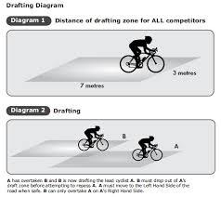

Additional places to park

LA8 8EA
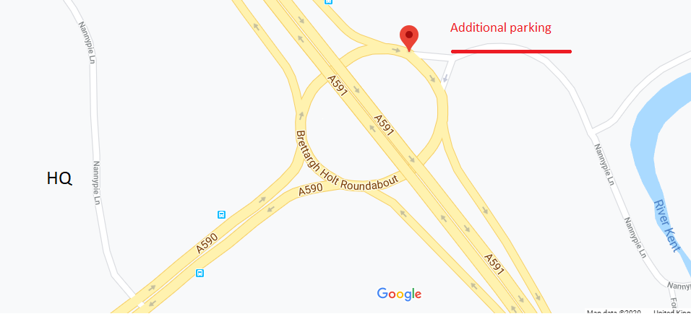

LA8 8EG
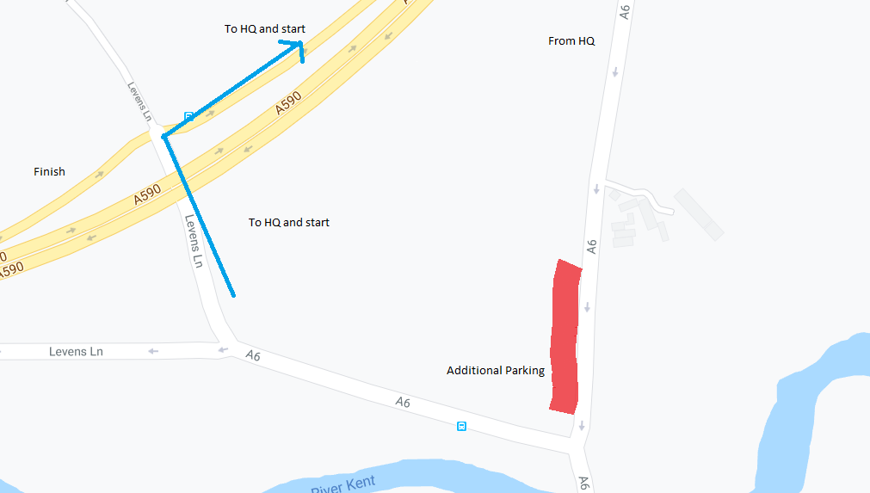

There are smaller laybys on the course A590 and the A6 and Nannypie Lane.

Please be considerate when parking and social distance at all times. Do not get changed, urinate or warm up in front of or in close proximity of any residential home.

